# C2- S5 - PRACTICE

*NOTE: check your* ***THEORY slides*** *to answer those questions!*

# EXERCISE 1 – GOOGLE CLASSROOM DATABASE

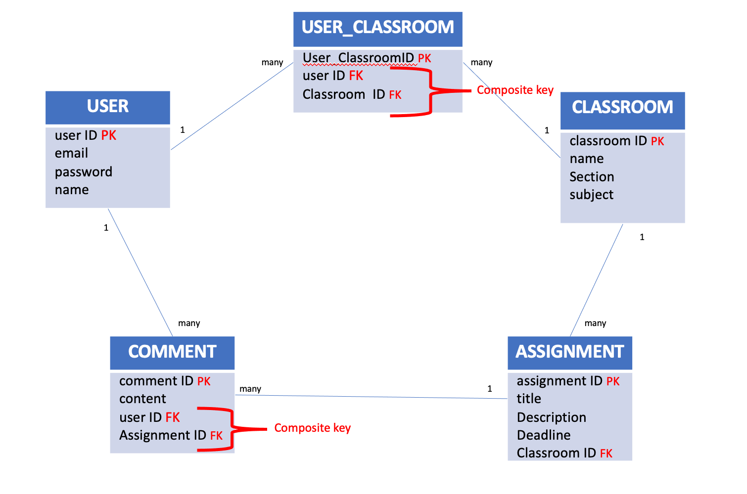

Here is the Entity Relation Diagram of the Google Classroom Database you designed in Chapter 1. You are now going to put it in MySQL!

**Q1 –** Write a statement to create the google classroom database, and to tell MySQL you are now working with it.

**Q2** – For each table (USER, USER_CLASSROOM, CLASSROOM, ASSIGNMENT, COMMENT), complete the following arrays, by specifying for each field:

* + The field type (SQL type) and size
  + Can be null or not?
  + Is a primary key or foreign keys?
* **USER TABLE**

|  |  |  |  |
| --- | --- | --- | --- |
| Field | Type / size | Null? | Key |
|  |  |  |  |
|  |  |  |  |
|  |  |  |  |
|  |  |  |  |

**USER_CLASSROOM TABLE**

|  |  |  |  |
| --- | --- | --- | --- |
| Field | Type / size | Null? | Key |
|  |  |  |  |
|  |  |  |  |
|  |  |  |  |

**CLASSROOM TABLE**

|  |  |  |  |
| --- | --- | --- | --- |
| Field | Type / size | Null? | Key |
|  |  |  |  |
|  |  |  |  |
|  |  |  |  |
|  |  |  |  |

**ASSIGNMENT TABLE**

|  |  |  |  |
| --- | --- | --- | --- |
| Field | Type / size | Null? | Key |
|  |  |  |  |
|  |  |  |  |
|  |  |  |  |
|  |  |  |  |
|  |  |  |  |

**COMMENT TABLE**

|  |  |  |  |
| --- | --- | --- | --- |
| Field | Type / size | Null? | Key |
|  |  |  |  |
|  |  |  |  |
|  |  |  |  |
|  |  |  |  |

**Q3** – Write the SQL statement to create the 5 tables with appropriate properties.

WARNING: Create the tables in the right order to respect the Foreign Key constraints.

**Q4 –** Write statements to insert at least 3 records in each table.

# EXERCISE 2 – FOODPANDA DATABASE

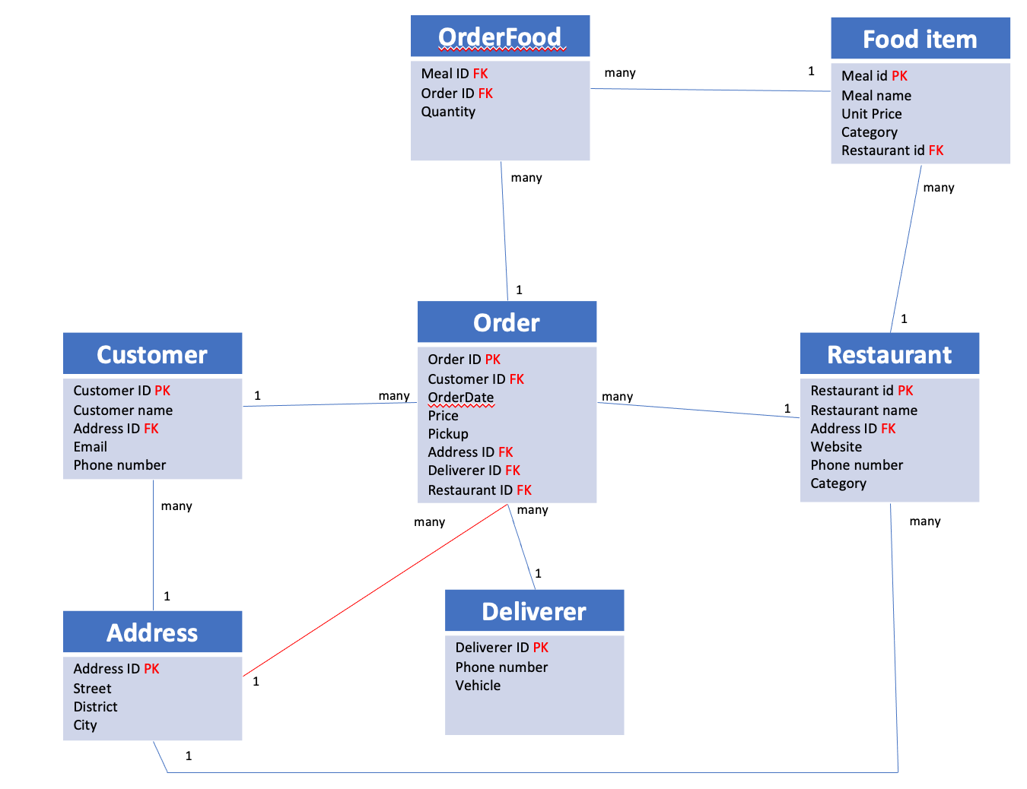

Here is the Entity Relation Diagram of the Foodpanda Database you designed in Chapter 1. You are now going to put it in MySQL!

**Q1 –** Write a statement to create the Foodpanda database, and to tell MySQL you are now working with it.

**Q2** – For each table of the database, complete the following array, by specifying for each field:

* + The field type (SQL type) and size
  + Can be null or not?
  + Is a primary key or foreign keys?

1. Address Table

|  |  |  |  |
| --- | --- | --- | --- |
| Field | Type / size | Null? | Key |
|  |  |  |  |
|  |  |  |  |
|  |  |  |  |
|  |  |  |  |

1. Customer Table

|  |  |  |  |
| --- | --- | --- | --- |
| Field | Type / size | Null? | Key |
|  |  |  |  |
|  |  |  |  |
|  |  |  |  |
|  |  |  |  |
|  |  |  |  |

**Q3** – Write the SQL statement to create the tables with appropriate properties.

WARNING: Create the tables in the right order to respect the Foreign Key constraints.

**Q4 –** Write statements to insert between 2 and 4 records in each table.